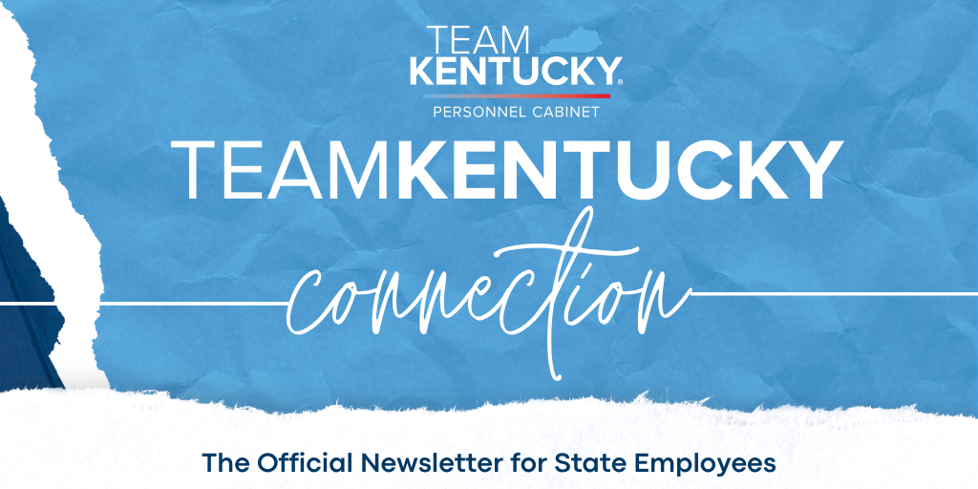
July 2024
Featured News  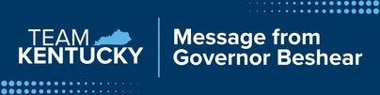  Hey, everybody—it’s Andy. I’m not able to speak to you all via video today, but I wanted to let you all know about the incredible things happening in our very own Kentucky State Parks.  This year, we’re celebrating the 100th anniversary of the Kentucky State Parks. Our Kentucky parks have been the setting of many fond memories with my family over the years, and I encourage you all to explore the wonderful parks that I, myself, have enjoyed so much.  To celebrate, Kentucky State Parks is offering state employees a 15% discount* with the code “SG15” through Oct. 31.  We hope you have a happy and safe summer. Remember, be kind and do good things. Thank you all.  *This discount includes one accommodation at a discounted rate per state employee per visit; it does not apply to campgrounds. Proof of government ID is required at check-in. Park special event weekends and holidays may be excluded depending on availability. It is not to be combined with other offers.    Effective Monday, July 1, state employees received a 3% salary increase pursuant to House Bill 6.  What does the salary increase mean?  Eligible employees received a 3% salary increase based on their current monthly salary or hourly rate. This is not to be confused with an annual increment. An example is provided below:  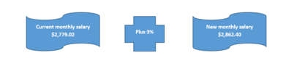  This means that over the course of twelve months, a current annual salary of $33,348.24 will increase by $1,000.56 for a new annual salary of $34,348.80.  When will the salary increase be received?  The salary increase became effective July 1, 2024, and it will be reflected in the pay received on Tuesday, July 30, 2024 (for the pay period of July 1-15, 2024).  Who is NOT eligible?  - Interim employees  - Day Laborers  - KRS Chapter 16 employees within the Trooper and Commercial Vehicle Enforcement (CVE) Officer series - These employees will receive a salary increase in compliance with KRS 16.052  Any questions pertaining to your eligibility or noneligibility for the salary increase should be directed to your agency Human Resources (HR) office.  On behalf of Gov. Beshear, we appreciate and thank you for your hard work and dedication for the services you provide to the Commonwealth of Kentucky.  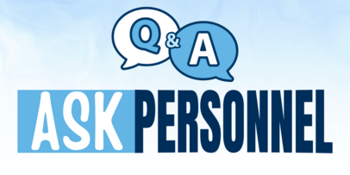  Ask Personnel  Are there topics that you would like clarity on in regard to your benefits or other personnel matters? We will be accepting inquiries that may be the subject of future newsletters. Email your inquiry for submission to PersCab.Correspond@ky.gov.    Charles W. Anderson Laureate Award &  IMPACT Award Nominations  The Personnel Cabinet is now accepting nominations for the prestigious Charles W. Anderson Laureate Award and the state employee IMPACT Award!  Nomination Deadline: July 22  Learn More & Submit a Nomination  The Anderson Award recognizes the achievements of Kentuckians who have made significant contributions to promoting equal employment opportunities, pioneered diversity initiatives or significantly contributed to the advancement of any protected class.  The IMPACT Award recognizes one current Executive Branch employee who, within the past year, has made significant contributions towards advancing diversity, equity and inclusion in the workplace.  These awards will be presented at the 2024 Governor’s Conference on Leadership, Equality, Accessibility & Diversity.  Have questions? Contact the Office of Diversity, Equality and Training at 502-564-8000​​.  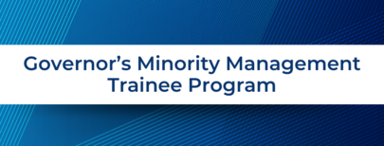  Governor's Minority Management Trainee Program Now Accepting Applications  The Governor’s Minority Management Trainee Program (GMMTP) application portal is now open! The GMMTP is a one-year leadership and professional development program created for Executive Branch minority employees who are currently in a grade 12 or higher job classification within the merit system.  Participants will receive in-depth, practical training through classroom instruction, hands-on experience and an opportunity to collaboratively facilitate special programming.  Through participation in the GMMTP, you can expect to have:  - Opportunities for individual growth, professional development and leadership training to assure readiness for management and executive level roles within the Commonwealth of Kentucky;  - Mentoring and networking opportunities for employees who are currently in management positions so they are able to develop professional relationships to assist them throughout their careers; and  - Value-added learning and development opportunities that will provide a statewide view of the many programs and initiatives that drive the work of all state employees.  Application Deadline: July 22  Start Your GMMTP Application    MyPERFORMANCE Mid-Year Interim Review  Today, July 3, performance-eligible employees will receive their 2024 Mid-Year Interim Review in MyPURPOSE.  Employees, you have an important role in the process. Providing feedback to your manager is essential, and it’s easy to do so by completing your Self-Review!  We encourage you to review resources on the Performance Management website and view the online tutorial, Guide to Performance Management, in MyPURPOSE. To ensure you receive the latest version of the online tutorial, follow the steps below.  - Log in to your MyPURPOSE account.  - Enter “Guide to Performance Management” in the search box in the upper right corner.  - Select the appropriate training depending on whether you are an employee or evaluator.  - If you are viewing the training for the first time, select the button that says “Launch.” If you have previously viewed the training, select the button that says “Request” and then “Request” again. This will ensure you view the most recent content.  For questions or assistance, please contact your agency HR office.    Tickets on Sale Now!  Tickets are now on sale for this year’s Governor’s Conference on Leadership, Equality, Accessibility and Diversity (LEAD) Sept. 18-19!  We can’t wait for you to see what’s in store for this year’s LEAD Conference! We are planning to make this year better than ever with a phenomenal lineup of guest speakers that you won’t want to miss, including some past favorites with new content, like Kristen Scroggins, Karim Ellis and so many more!  Click here to learn more & purchase your ticket!    Ready for Open Enrollment?  The Open Enrollment period for health, life, dental and vision insurance will be Oct. 7 through Oct. 25, 2024. In preparation for Open Enrollment, we are also coordinating Benefit Fairs throughout the state to help you learn more about the incredible programs and opportunities available to members of the Kentucky Employees’ Health Plan! See below the details for each Benefit Fair.  Russell County Auditorium - Natatorium Complex  10/1/24 from 2-6 p.m. CDT  2167 US-127 Russell Springs, KY 42642  Kentucky State Office Building Auditorium  10/2/24 from 8 a.m.-6 p.m. EDT  501 High St. Frankfort, KY 40601  Owensboro Board of Education  10/3/24 from 2-6 p.m. CDT  450 Griffith Ave. Owensboro, KY 42431  Hopkins County Career & Tech Center  10/4/24 from 2-6 p.m. CDT  1775 Patriot Drive Madisonville, KY 42431  Pike County Central High School Cafeteria  10/8/24 from 2-6 p.m. EDT  100 Winners Circle Drive Pikeville, KY 41501  More information on Open Enrollment will be coming out in August. If you have any questions about these events, please call the Department of Employee Insurance at 502-564-6534.    We are proud to announce the final totals for the 2023 Kentucky Employees Charitable Campaign! Last year, you all helped raise an incredible $602,973 through payroll deductions, one-time gifts and special events.  We have seen a 47% increase in giving since 2021, which shows a tremendous commitment from Team Kentucky to support their communities and Kentucky families through the KECC initiative. The efforts of KECC coordinators, the support of executive leadership and the generosity of donors have made a significant impact in expanding services and positively affecting lives across the commonwealth.  Your collective efforts are creating a brighter future for all! Thank you for your generosity!  2024 Governor's Ambassador Award Winners  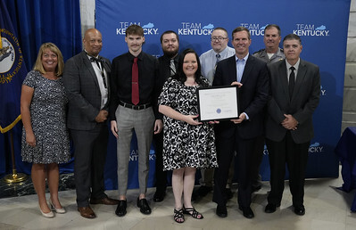  Congratulations to our 2024 Governor’s Ambassador Award winners! This year, the Personnel Cabinet received 113 nominations for the awards, which celebrate community service and volunteerism, courage, customer service, leadership, professional achievement and teamwork.  Click here to read more about the winners and their remarkable achievements.    Consider using your salary increase to give your retirement savings a boost!  If you are receiving a salary increase, consider increasing your contributions. Small adjustments you make today can help pave the way to a more secure future.  If you’ve recently paused or scaled back on your retirement contributions, this is a good time to realign with your long-term financial objectives and get back on track. By setting the strategic plan in motion now, you can make a big difference in achieving your retirement goals and help ensure that financial stress doesn’t cloud your golden years.  Get started at kentuckydcp.ky.gov!    Are you considering outside employment?  As a reminder, if you have other employment you intend to maintain outside of your state government job, you must complete the Outside Employment: Employee Request and Agency Response form to request approval. The form is available on the Personnel Cabinet’s website under Documents in Demand. The completed request form should be given to your supervisor, who will route it through your agency, as appropriate, to ensure there is no potential conflict of interest in maintaining both jobs. This includes self-employment and work as an independent contractor. If you have any questions or need assistance with the request form, please contact your agency’s human resource office.  Unique State Library Services Available to State Employees  Sign up for a State Library Account today to unlock services available only to state employees! With a valid State Library account, state employees have access to online research databases, the State Library’s collections, interlibrary loans (ILL) and downloadable audiobooks and eBooks. So much is online, but employees can also visit 300 Coffee Tree Road in Frankfort to access special displays and special access to materials such as records, genealogy resources or the Kentucky Talking Book Library for the Blind and Print Disabled. Click here to learn more, apply for your account and to browse all State Library services!    Upcoming Professional Development Opportunities  View the professional development opportunities provided by the Kentucky Employees Assistance Program (KEAP) and Governmental Services Center. Employees should log in and request training under “MyLEARNING” – “Event Calendar” in MyPURPOSE.  Manager approval is required.  *Designated workshops are eligible for continuing education credit for credential holders. KEAP is an approved sponsor of continuing education by the KY Board of Examiners of Psychology, the KY Board of Social Work and the KY Board of Alcohol & Drug Counselors.  July  - Budgeting for Healthy Eating: Wednesday, July 3, 10:30-11:30 a.m. EDT  - *Training People How To Treat You: Tuesday, July 9, 10:30-11:30 a.m. EDT  - *Burnout: Definitions, Diagnosis and Prevention: Wednesday, July 10, 10:30-11:30 a.m. EDT  - Working Through Change: Thursday, July 11, 10 a.m.-noon EDT  - Defining Leadership: Thursday, July 18, 10 a.m.-noon EDT  - Understanding Your Social Style: Thursday, July 25, 10 a.m.-noon EDT  August  - Developing Your Leadership Plan: Thursday, Aug. 1, 10 a.m.-noon EDT  - *Happiness at Work – for Employees: Tuesday, Aug. 6, 10:30-11:30 a.m. EDT  - Adapting Your Social Style: Thursday, Aug. 8, 10 a.m.-noon EDT  - *Happiness at Work – for Supervisors: Wednesday, Aug. 14, 10:30-11:30 a.m. EDT  - Driving Results Through Communication: Thursday, Aug. 15, 10 a.m.-noon EDT  - *Your Most Healthy Brain: Wednesday, Aug. 21, 10:30-11:30 a.m. EDT  - Excellent Customer Service: Thursday, Aug. 22, 10 a.m.-noon EDT  - Choosing To Be Accountable: Thursday, Aug. 29, 10 a.m.-noon EDT    Get Connected: Employee Resource Groups (ERGs)  ERGs are committed to creating a sense of belonging among all state government employees, developing programming, conducting events/activities and supporting community initiatives.  Participation in an ERG is voluntary and open to all Executive Branch employees. Currently, there are eight ERGs that employees can choose from:  - Accessibility  - Asian American or Pacific Islander  - Black or African American  - Hispanics and Latinos  - Lesbian, Gay, Bisexual, Transgender and Queer (LGBTQ)  - Multi-Generational  - Veterans  - Women  Click here to learn more about ERGs | What's in this edition?  - Message from the Governor  - Salary Increase Information  - Ask Personnel  - Award Nominations  - Governor's Minority Management Trainee Program Application  - MyPERFORMANCE Mid-Year Interim Reviews  - KyLEAD Conference  - KEHP Benefit Fairs  - KECC 2023 Totals  - Governor’s Ambassador Awards Recap  - Kentucky Deferred Comp  - Outside Employment Reminder  - State Holidays  - State Library Services  - Professional Development Opportunities  - Employee Resource Groups  Get Started on MyPURPOSE Today!  - Access over 2,000 online training courses and webinars.  - Connect with team members virtually.  - Apply for career opportunities.  CLICK HERE TO ACCESS PERSONNEL EVENT CALENDAR  BLOOD DONATIONS NEEDED!  Click here for Blood Donation Information
  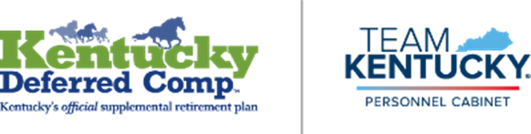
  Holidays for State Personnel
  State offices shall be closed and state employees shall be given a holiday on the following days:
  - Thursday, July 4 – Independence Day
  - Monday, Sept. 2 – Labor Day
  - Tuesday, Nov. 5 – Presidential Election Day
  - Monday, Nov. 11 – Veterans Day
  - Thursday & Friday, Nov. 28-29 – Thanksgiving
  - Tuesday & Wednesday, Dec. 24, 25 – Christmas
  - Tuesday & Wednesday, Dec. 31, Jan. 1 – New Year's​​​ ​​​
  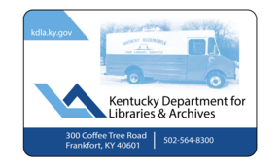
  
  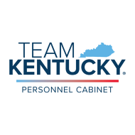

About the Personnel Cabinet
The Personnel Cabinet provides leadership and guidance to attract, develop, motivate, and retain a talented, diverse workforce that provides outstanding service to state agencies and citizens of the Commonwealth; foster an understanding of and adherence to legal requirements; and create a positive and inclusive work environment that supports the holistic well-being of all employees.

The Personnel Cabinet is located at 501 High Street, Frankfort, KY 40601
Normal business hours are from 8 a.m. to 4:30 p.m.
EEO Statement
The Commonwealth of Kentucky does not discriminate on the basis of race, color, sex, disability, age, national origin, religion, sexual orientation, gender identity or expression, pregnancy or related medical condition, marital or familial status, ancestry, political affiliation, genetic information, or veteran status in accordance with state and federal laws.

CONTACT US

